DevOps Task – Day 2
GIT – CLI configuration, SSH key creation and GitHub authentication
Field | Details
Name | Chandru
Date | 08-10-2026
Batch | 14
Topic | Git CLI configuration, SSH public key and GitHub authentication (Day 2)

1. Check the Git Version
Check the version of Git installed on your Linux machine.
git --version
Output on the machine: git version 2.25.1

2. Configure User Email and Name
git config --global user.email "you@example.com"
git config --global user.name "Your Name"
Replace "you@example.com" with the email address linked to your GitHub account. This makes sure that the commits you push to GitHub are linked to your GitHub account. The user name can be any name.

Setting the Git user email and name

3. Verify the Configuration
Check that the above commands worked:
git config --global --list
Saved Git configuration (user.email and user.name)

4. Create an SSH Key Pair
ssh-keygen -t rsa -b 4096 -C "your_email_id"
Option | Meaning
-t rsa | Type of key – RSA
-b 4096 | Number of bits in the key – 4096
-C "email" | Comment – usually your email ID

- File location: press Enter to accept the default (~/.ssh/id_rsa).
- Passphrase: leave it empty and press Enter.
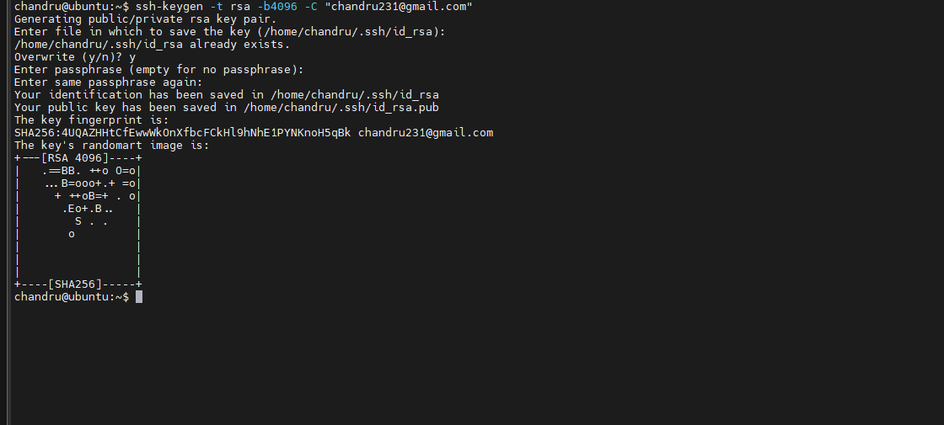
Generating the RSA 4096-bit key pair

5. Add the Private Key to the SSH Agent
eval "$(ssh-agent -s)"
ssh-add ~/.ssh/id_rsa
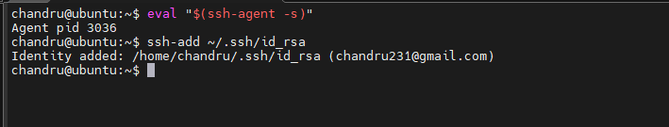
Starting the SSH agent and adding the private key

View and copy the public key
Go to the .ssh folder and list the key files:
cd /home/chandru/.ssh
ls
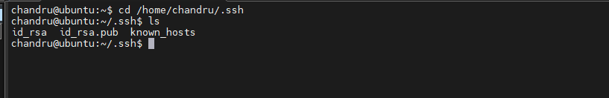
Key files: id_rsa (private), id_rsa.pub (public), known_hosts
Display the public key and copy the full line (starting with ssh-rsa):
cat ~/.ssh/id_rsa.pub
Public key – this is the part to copy into GitHub
Note: Copy only id_rsa.pub (the public key). Never share or paste id_rsa (the private key).

6. Add the Public Key to GitHub
- In GitHub, click your Profile picture → Settings.
- On the left side, click SSH and GPG keys.
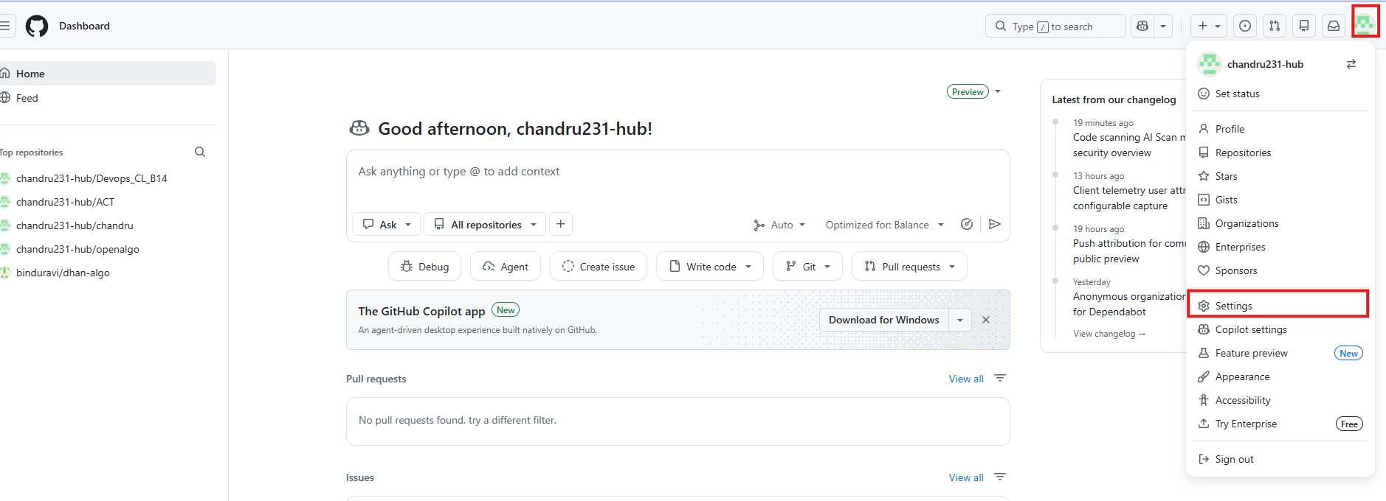
GitHub Settings → SSH and GPG keys
- Click New SSH key.
- Enter a name (title) for the key.
- Paste the copied public key into the Key box and click Add SSH key.
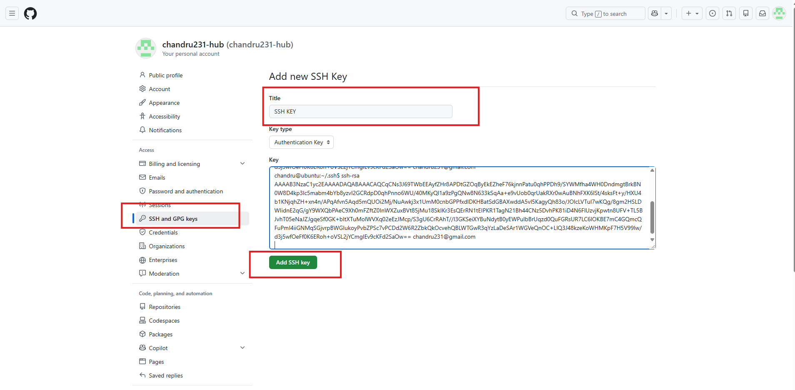
Adding the new SSH key

Confirm access (email verification)
GitHub asks you to confirm your identity. Click Verify via email.
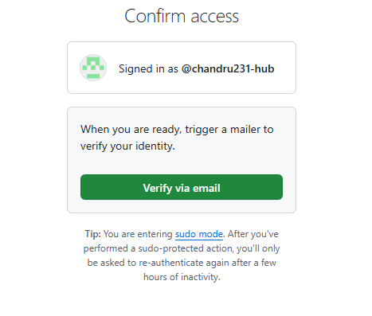
Confirm access – Verify via email
Open the email from GitHub and copy the verification code.
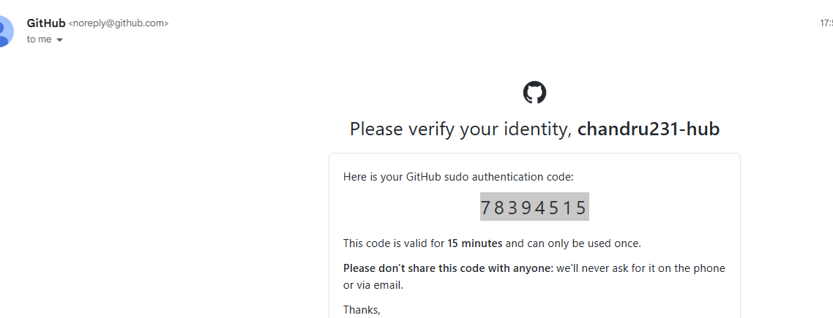
Verification code received by email
Enter the code and click Verify.
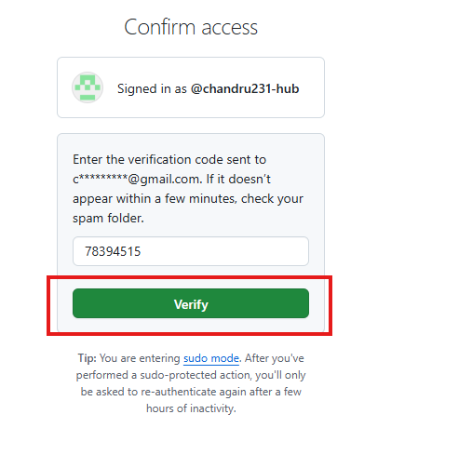
Entering the verification code
The key is added and appears under Authentication keys.
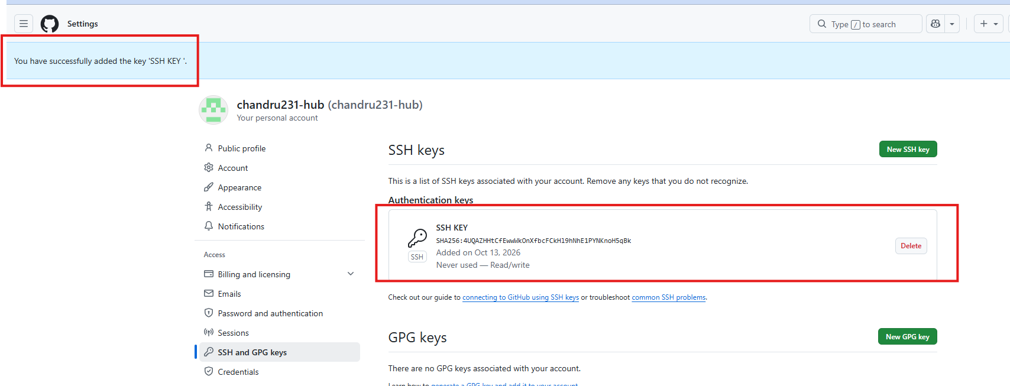
SSH key successfully added to the GitHub account

7. Test the SSH Connection to GitHub
ssh -T git@github.com
If successful, you will see: "Hi your-username! You've successfully authenticated…"
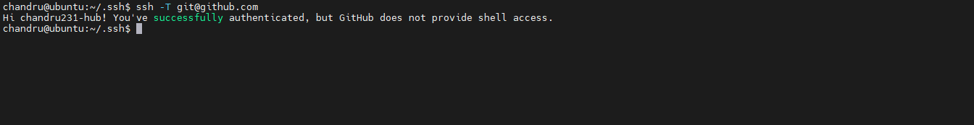
Successful SSH authentication to GitHub

8. Why Add the Private Key to the SSH Agent?
- The private key (id_rsa) is secret and is never shared.
- You add it to the SSH agent so the agent can use it to prove your identity during authentication, without exposing the key itself.
ssh-add ~/.ssh/id_rsa
The SSH agent then "remembers" this key and uses it when Git connects to GitHub.
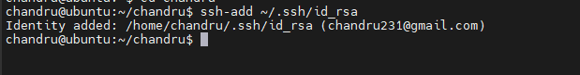
Private key added to the SSH agent

9. Why Add the Public Key to GitHub?
- The public key (id_rsa.pub) is meant to be shared.
- You paste it into GitHub's SSH key settings.
- GitHub stores this key and uses it to recognise you when your private key is used to connect.
Key | File | Kept where | Shared?
Private key | ~/.ssh/id_rsa | Your machine (SSH agent) | Never
Public key | ~/.ssh/id_rsa.pub | GitHub account settings | Yes

10. How It Works Together
What happens when you push to GitHub over SSH:
git push origin main
- Git uses SSH to connect to git@github.com.
- GitHub says: "I have this public key on file. Prove you have the matching private key."
- Your SSH agent replies with a signature made using your private key.
- GitHub checks the signature with your public key and allows access if they match.
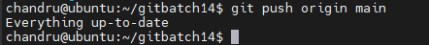
Push over SSH – authenticated (nothing new to push, so "Everything up-to-date")

